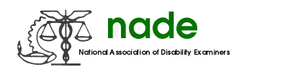

To: NADE Board of Directors
From: Jennifer Reimer, DDS Boise
Date: August 10, 2020
Subject: NADE Organ Donation Committee End-Year 2020 Report

Hello,
I hope this finds you safe & healthy. I reached out to the committee members in the spring and we agreed to hold off on any events due to Covid-19. I do not believe any of us realized four months later we would still be in this pandemic. With that said, there is nothing to report.

Thank you,

Jennifer Reimer

