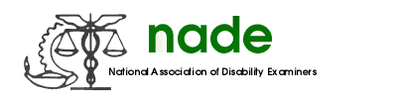

To: NADE Board of Directors
From: Melissa Williamson, National Membership Director
Date: August 31, 2020
Subject: NADE Membership End Year 2020 Report

Since August 2019, I have:

- Communicated with the Chapter Presidents who have contacted me regarding membership questions.

- Corresponded with the Regional Directors, Treasurer and Web Master regarding any membership issues or questions.

- Issued Membership Grants as requested by the local Chapter Presidents.

- Prepared and distributed membership rosters to the board.

- Processed all Paypal membership payments.

- Prepared and mailed New Membership Packets

- Corresponded with the Corporate members regarding membership renewals

- Sent email correspondence to nine previous Corporate members in attempt to recruit them back to NADE.

- Earlier in the year, I contacted 10 of our past Corporate members to try to build upon that membership area. However, I did not receive any return correspondence from these contacts.

Respectfully submitted,
Melissa Williamson
National Membership Director

