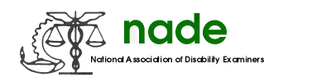

To: NADE Board of Directors
From: Stephani Sanford
Date: February 13, 2019
Subject: NADE Support Staff Committee Midyear Report

The Support Staff Committee continues to work on recruiting new support staff members as well as retaining current members. We have shared ways in which our chapters generate interest, reminder support staff that NADE is an organization for all DDS employees, not just examiners. A couple of chapters have already had successful membership drives. One member noted they are hosting an ice cream social to recruit new members, while another chapter hosted several fundraisers in January to contribute to membership fees for new members.

We also continue to spread the word to support staff that the committee is an excellent way to get their concerns and ideas heard. Committee members recently discussed DCPS rollout and what affects that has had on support staff. One member notes that they have already begun working in DCPS and was able to give some insight on how it is working for them.

The Support Staff Committee has communicated by email about issues that are unique to NADE Support Staff Members. . Currently, our committee consists of Rosslyn Casey O’Neal, Washington D.C.; Tena Fleming, Alabama; Denise Hernandez, Colorado; Glenda Dunn, Georgia; and Stephani Sanford, Montana.

Respectfully,
Stephani Sanford
Support Staff Committee Chairperson

