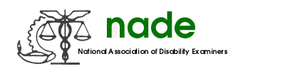

To: NADE Board of Directors
From: Hope Shaw, Chair
Date: February 14, 2019
Subject: NADE Organ Donation/Transplant Committee Mid-Year 2019 Report

There is nothing or no activities to report for September – February. The committee will distribute flyers to NADE chapters in March 2019 with information about the NADE Organ Donation Contest and promote National Donate Life Month and Organ Donation in April 2019. These efforts will be noted on the 2019 Year End Report.

Respectfully Submitted,

Hope Shaw, Chair

