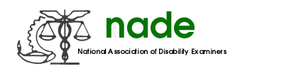

To: NADE Board of Directors
From: Alice Rich, NE NADE Director
Date: 2/10/19
Subject: NE NADE 2019 Middle of Year Report

We continue to experience increased and changing workloads across the country. It is no different in the Northeast, which explains the decreased NADE activity among our NE Chapters.

However, with that said, I am delighted to report activities in the Northeast to increase membership are underway.

We requested two membership grants that will be utilized to increase membership in our New York and Vermont NADE Chapters.

New York and Vermont NADE Chapters have also been the recipients of grants from the Northeast Region to increase membership.

There are Lunch and Learns, NADE presentations to new adjudicator classes, membership drives for retired NADE non-members and members alike, membership rebates, morale-boosting social activities, the restarting of a NADE Chapter Newsletter, and continued brainstorming within the chapters on how to best increase and serve the membership.

For the rest of the year in the North East, we look forward to increasing our membership and NADE activities.

