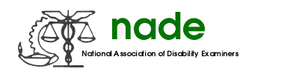

To: NADE Board of Directors
From: Molly Turnbull
Date: 02/13/19
Subject: NADE Elections and Nominations Committee Mid-Year 2019 Report

Committee members have been contacted. There are no activities to report at this time.

