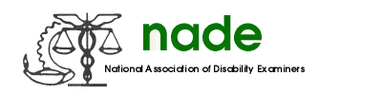

To: NADE Board of Directors
From: Sara Winn, NADE Communication Director
Date: 02/12/2019
Subject: 2019 Mid-Year Report

It is a pleasure serving as the NADE Communications Director for 2019. At the National Training conference, chapters were awarded for photos and newsletters. I published the conference advocate in October 2018. I have also ensured that the pictures from the conference were available to purchase on the website. I also communicated with Amanda regarding updates to the website for ease of use. I will be publishing another advocate after the mid-year board meeting.

Sara Winn
NADE Communications Director

