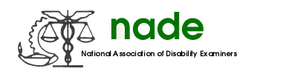

To: NADE Board of Directors
From: Shiba Nixon
Date: August 3, 2018
Subject: NADE Professional Relations Officers Committee End-Year 2018 Report

Nothing or no activities to report.

Thanks,
Shiba Nixon RN PRO

