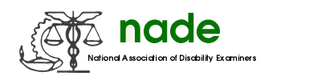

To: NADE Board of Directors
From: Richard Clark, Chair
Date: 07/24/18
Subject: NADE Awards Committee End of Year 2018 Report.

The committee submitted the awards criteria to the national chapters in March 2018 with a deadline of June 8th. The awards committee reviewed all submitted awards nominations for the 2017/2018 national awards by the end of June. There were 37 nominations overall which were considered and voted upon by the committee. Discussion of the new Medical Consultant award design was also completed. Finalized nominee information was submitted to Julie Kujath in July, for plaque creation. The awards will be presented at the upcoming awards ceremony in August 2018.

Respectfully Submitted,

Richard Clark

Richard Clark, Awards Committee Chair

