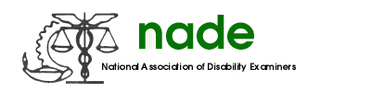

To: NADE Board of Directors
From: Shiba Nixon
Date: 2/16/2018
Subject: NADE Professional Relations

Nothing to report.

Thanks,
Shiba Nixon RN PRO

