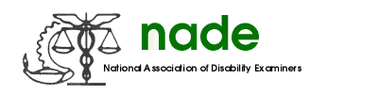

To: NADE Board of Directors
From: Melissa Williamson, National Membership Director
Date: February 2018
Subject: Mid-Year Membership Report

Since August 2017, I have:

- Communicated with the Chapter Presidents who have contacted me regarding membership questions.

- Corresponded with the Regional Directors, Treasurer and Web Master regarding any membership issues or questions.

- Issued Membership Grants as requested by the local Chapter Presidents.

- Prepared and distributed membership rosters to the board.

- Processed all Paypal membership payments.

- Corresponded with the Web Master to correct issues with the membership database.

- Prepared an article for The Advocate regarding the January Membership Drive.

- Prepared and mailed New Membership Packets

- Corresponded with the Corporate members regarding membership renewals

I would like to thank everyone for their hard work in increasing membership and would like to encourage everyone to continue working to increase our membership. It is an honor to serve with such dedicated individuals on this NADE Board.

Respectfully submitted,
Melissa Williamson
National Membership Director

