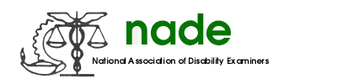

To: Tonya Scott, NADE Secretary 2017-2018
From: Sara Winn, Communications Director 2017-2018
Date: 02/15/2018
Subject: NADE Communications Mid Year 2018 Report

As communications director, I took more than 400 pictures at the National conference. I also headed a committee to judge the photo competition and newsletter competition. Awards were presented at the National NADE conference in Detroit in 8/2017. This included pictures of the NADE award winners. Many of the pictures were published in the National Conference Edition Newsletter released in November 2017. I also created a paypal link which made purchase of the pictures available. I sent CD’s to Julie to send to anyone who ordered pictures. I worked closely with Jennifer Pounds and Amanda Underwood to update information and pictures for the website. This included updating the NADE merchandise and pictures and addresses for changing members of the board.

I plan to take pictures at the midyear meeting in Baltimore. I also plan to publish another edition of the newsletter following mid-year. I have already received updates from chapters who want to have the articles published. I look forward to serving the remainder of the year as Communications Director.

Sara Winn
NADE Communications Director 2017-2018

