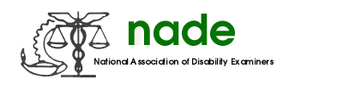

To: Stephanie Wilson
From: Sara Winn, Communications director
Date: 07/27/2017
Subject: End of Year Report

2016-2017 year was busy year for me as Communications director. With the webmaster stepping down, it was a challenge to upload the Advocate and make changes to the website. During the year, I produced five advocates for members to enjoy. I recently participated in a conference call and we were able to secure a webmaster. Already, she has updated the website to reflect the new prices for the NADE store and has made other crucial changes.

I along with my committee have judged pictures and newsletters submitted from throughout the nation and we will present awards to the winning chapters at the National conference.

I look forward to serving as Communications director 2017-2018 and working with the webmaster to bring the NADE website up to date.

Sincerely,
Sara Winn

