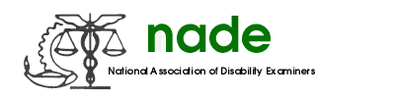

To: NADE Board of Directors
From: Tonya Scott, President-Elect
Date: 06/24/2016
Subject: 2016 End Year Report

It has been my honor and pleasure to serve in the capacity of President-Elect this last year. This past year I have had the benefit of a great mentoring team in Sharon Summers, Jeff Price and Jennifer Nottingham. I am looking forward to serving the membership as President.

My activities this past year include the following:
- Attended and participated in the Mid-Year Board Meeting in Baltimore, Maryland;
- Participated in the Washington, D.C. Hill visits with congressional offices, various agencies, and SSA Acting Commissioner Colvin;
- Participated on various conference calls with Ann Robert, SSA Associate Commissioner for Disability Determinations and the NADE Board.
- Searched, contacted and appointed various members to serve on the upcoming 2016-2017 Board.
- Contacted the Royal Sonesta Hotel in Baltimore for the upcoming Mid-Year Board Meeting 2017; a contract has been finalized.

I appreciate the opportunity to serve this distinguished, diverse and amazing association!

Best regards,

Tonya M. Scott

