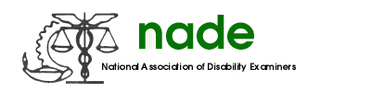

To: NADE Board of Directors
From: Kimberly Underwood, Great Plains Regional Director
Date: July 13, 2016
Subject: Region End of Year Report

The Great Plains Region chapters have worked diligently over the past year to increase membership, educate members and non-members about NADE and raise money for charitable organizations. As the Regional Director, I have worked with each state to help them in any way I can to increase their membership and knowledge of NADE.

Colorado is busy preparing for the NADE conference this year. They are working hard to make sure we all have a great experience. I have been available to them for any questions have helped them with anything they have asked of me.

We had multiple states hold activities to celebrate NDPW and Organ Donation month. There were multiple fundraisers held to support charitable organizations and fellow DD employees who were in need. The Great Plains Region shows how caring and compassionate they are not only in the work they do each day but also in the thoughtful way they reach out to others who need assistance.

I have enjoyed my time as Regional Director. I feel privileged to serve in this capacity and work with all the wonderful people of NADE.

Respectfully submitted,
Kimberly Underwood

