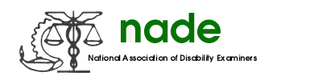

To: NADE Board of Directors
From: Crystal Bach
Date: 02/12/2016
Subject: NADE Secretary 2016 Mid-Year Report

It has been my honor to serve as the NADE Secretary these past few months. I appreciate everyone who has reached out to me, and/or who I have sought out for assistance, for their help through this time. I have learned a lot and continue to grow as NADE Secretary every month.

During this time I prepared the minutes of the 2015-2016 New Board Meeting, and from the various conference calls conducted in Fall 2015. Appropriate minutes have been posted to the NADE website.

I have gathered up the 2016 Mid-Year reports of all NADE Board members, Regional Directors, Appointed Directors, and Committee Chairpersons. Electronic copies of the available reports were distributed to the same.

I look forward to continuing to grow in my position as NADE Secretary and of being of use to anyone who needs help or information.

Respectfully,

Crystal Bach
NADE Secretary

