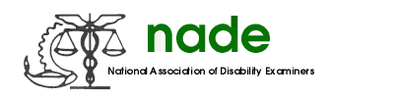

To: NADE Board of Directors
From: Tonya M. Scott, President-Elect
Date: January 20, 2016
Subject: 2016 Mid-Year Report

It was an honor and a privilege to be elected President-Elect and to serve the Membership of NADE in this capacity. I have strived to fulfill the duties and responsibilities of the NADE President-Elect to the best of my abilities.

- I have participated on Quarterly Conference Calls with other NADE Executive Officers and SSA’s leadership in order to keep the communication open for discussion of issues and concerns of importance to NADE members.

- I have participated in conference calls with the NADE Board to discuss various issues including the new NADE website and matters regarding the conference in 2016 in Denver, CO.

- I have enlisted the assistance of Barbara Mulligan of Helms Biscoe to provide information regarding the most cost efficient and suitable location for the Mid Year 2017 meeting.

- With the excellent mentoring of President Sharon Summers and Past Presidents Jeff Price and Jennifer Nottingham, I am preparing myself to serve as NADE President for 2016-2017.

I thank you for the opportunity to serve.

Tonya M. Scott

