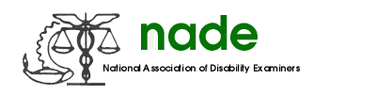

To: NADE Board of Directors
From: Thomas Gautier, THADE
Date: August 9, 2015
Subject: NADE Year-end Organ Donation/Transplant 2015 Report

The Organ Donation/Transplant Committee for 2015 is as follows:
Gautier, Thomas DDS Raleigh, NC Thomas.Gautier@ssa.gov, Chairperson

McGhee, Joyce DDS Birmingham, AL Joyce.Mcghee@ssa.gov

Edwards, Brenda DDS Detroit, MI Brenda.Edwards@ssa.gov

Marino, Jonathan DDS Roanoke, VA Jonathan.Marino@ssa.gov

April is Organ Donation Awareness Month at which time the customary contest was held amongst the chapters. Contest information was distributed to all the chapters, along with some ideas on how to increase awareness about Organ Donation.

We had five chapters to compete this year, and each one did an unbelievable job of creating avenues to show the importance of Organ Donation/Transplant with displays and guest speakers.

The winners are as follows:

Michigan, (MADE) – First Place
North Carolina, (THADE) – Second Place
Alabama, (AADE) – Third Place

Certificates and prize money will be given out at the NADE National Training Conference in Portland, Oregon for the winners.

Respectfully Submitted,
Thomas Gautier

