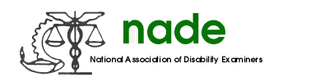

To: NADE Board of Directors
From: The Awards Committee
Date: 7/16/15
Subject: Year End Report

We are pleased that the Awards Nominations process went very well. We had many (close to thirty) terrific nominations!! All nominations were received on time, and the Committee Members did an outstanding job in reviewing the submissions and getting their votes in to me in a timely manner. We wish to thank Julie Kujath for her kind assistance in ordering the Awards and taking on the task to get them to Oregon. The Awards Committee congratulates all 2015 Nominees and the Award winners.

On another note, I would like to suggest a change to the Charges of the Awards Committee. We have noted that NADE has traditionally provided advance notification to DDS Directors of NADE awards winners in hopes of securing funding for these individuals to attend the conference to receive their award in person. In recent years, DDS Directors have reported it is no longer possible to provide such funding. Since this budget climate is expected to continue in the years ahead, we recommend that NADE discontinue its practice of providing such advance notification unless the Association can be confident that such notification will produce the desired outcome. We submit this for your consideration.

Respectfully Submitted,

Lisa Hayes, Chair

Committee Members:
Patty Glaunert
Crystal Bach
Meredith Rogan
Sheila Sheridan
Susan Hammett

