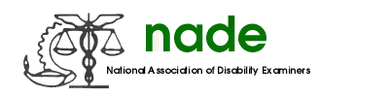

To: NADE Board of Directors
From: Kimberly Underwood
Date: February 13, 2015
Subject: Great Plains Regional Director Mid-Year report

I have maintained contact with the Great Plains region on a regular basis, sending the membership reports monthly and passing along any important information to the region and obtaining responses from the region as requested.

I procured volunteers within the Great Plains region to serve on NADE national committees.

I have worked with all the states within my region to increase membership by offering incentives, giving advice and sending information to the individual states as needed. Since August, the Great Plains region has increased membership by over 30%, which was the goal set by President Jeff Price at the end of year meeting.

I am working closely with each state and Julie Kujath to obtain the proper paperwork for each state for the tax incorporation.

I have enjoyed my time on the NADE Board and hope to assist both my region and the NADE Board in pursuing NADE’s purpose.

Respectfully submitted,

Kimberly Underwood
NADE Great Plains Regional Director

