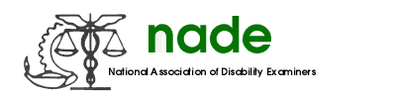

To: NADE Board of Directors
From: Kimberly Underwood
Date: August 12, 2014
Subject: Awards Committee

Submissions were received from NADE members and National Award recipients have been chosen. Awards were ordered from MVE (Missouri Vocational Enterprise) and will be presented at the Awards Luncheon during the NADE conference in August 2014.

Respectfully submitted,

Kimberly Underwood

